Experiment 1

Student Name: Aditi R Sinha UID: 22BCS15130

Branch: BE-CSE Section/Group: 22BCS_KRG_IOT-2-B

Semester:6th Date of Performance: 11/01/2025

Subject Name: Project Based Learning Subject Code: 22CSH-359 in Java with Lab

1. Aim: Given the following table containing information about employees of an organization, develop a small java application, which accepts employee id from the command prompt and displays the following details as output:

Emp No Emp Name Department Designation and Salary

You may assume that the array is initialized with the following details:

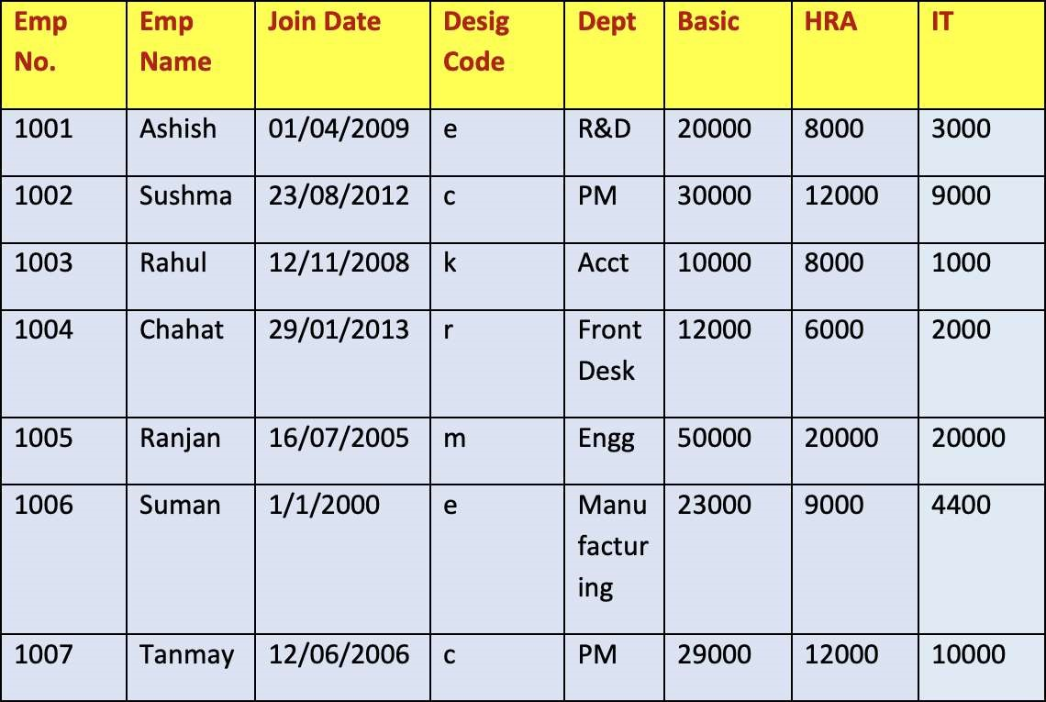

Salary is calculated as Basic+HRA+DA-IT. (DA details are given in the Designation table)

Designation details :

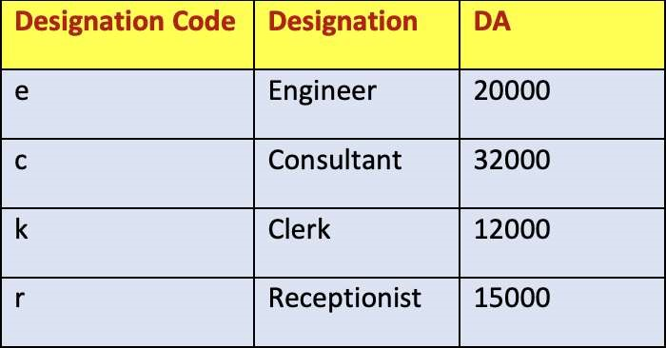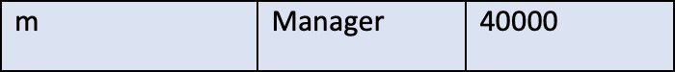

Use Switch-Case to print Designation in the output and to find the value of DA for a particular employee.

1. Objective:

i. Assuming that your class name is Project1, and you execute your code as java Project1 1003, it should display the following output :

Emp No. Emp Name Department Designation Salary

1003 Rahul Acct Clerk 29000 ii. java Project1 123

There is no employee with empid : 123

1. Implementation/Code:

import java.util.Scanner;

class Employees { public int empNo; public String empName; public char designCode; public int basic; public int HRA;

public int IT;

Employees(int empNo, String empName, char designCode, int basic, int HRA, int IT) {

this.empNo = empNo; this.empName = empName; this.designCode = designCode;

this.basic = basic; this.HRA = HRA; this.IT = IT;

}

}

class DesignationDetails { public String designation; public int DA;

DesignationDetails(String designation, int DA) {

this.designation = designation; this.DA = DA;

}

}

public class exp1 {

public static DesignationDetails degDetails(char designCode) { switch (designCode) { case 'e':

return new DesignationDetails("Engineer", 20000); case 'c':

return new DesignationDetails("Consultant", 32000); case 'r':

return new DesignationDetails("Clerk", 12000); case 'k':

return new DesignationDetails("Receptionist", 15000); case 'm':

return new DesignationDetails("Manager", 40000); default:

return new DesignationDetails("Unknown", 0);

}

}

public static void main(String[] args) {

Scanner input = new Scanner(System.in);

Employees[] arr = { new Employees(1001, "Ashish", 'e', 20000, 8000, 3000), new Employees(1002, "Sushma", 'c', 30000, 12000, 9000), new Employees(1003, "Rahul", 'k', 10000, 8000, 1000), new Employees(1004, "Chahat", 'r', 12000, 6000, 2000), new Employees(1005, "Ranjan", 'm', 50000, 20000, 20000), new Employees(1006, "Suman", 'e', 23000, 9000, 4400), new Employees(1007, "Tanmay", 'c', 29000, 12000, 10000)

};

System.out.print("Enter employee number to see info: "); int val = input.nextInt();

boolean found = false;

for (Employees emp : arr) { if (val == emp.empNo) {

DesignationDetails details = degDetails(emp.designCode); int totalSal = details.DA + emp.basic + emp.HRA - emp.IT;

System.out.println("Employee Info:");

System.out.println("Number: " + emp.empNo);

System.out.println("Name: " + emp.empName);

System.out.println("Designation: " + details.designation);

System.out.println("Total Salary: " + totalSal); found = true; break;

}

}

if (!found)

{

System.out.println("There is no employee with Employee Number " + val);

}

input.close();

}

}

1. Output:

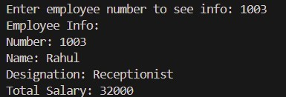



1. Learning Outcomes:

i. Understanding of Class and Object Concepts in Java ii. Implementation of Arrays and Iteration iii. Implementation of Scanner Class in Java